**Interaction/Effect Modification**

treatment effect is different over different strata of the population defined by a baseline covariate

e.g. age, sex, study center, region, baseline prognostic factors

not due to imbalance in the data

Quantitative Interaction Qualitative Interaction

direction of effect stays the same over strata direction of effect differs over strata

magnitude differs over strata

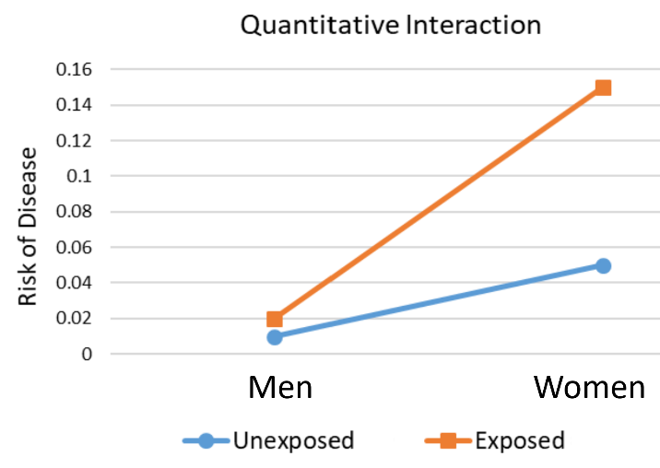 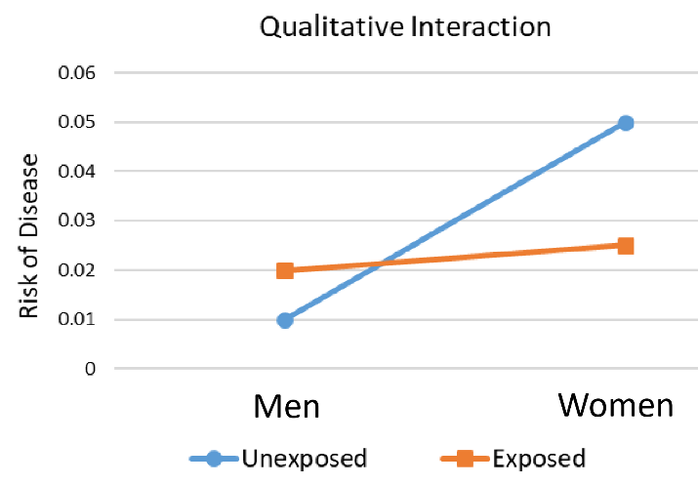

Potential Issues

treatment may be beneficial to some subgroups but harmful to others

can’t provide a single summary measure, perform separate analysis for each stratum

sample size for each strata will be smaller than the whole trial population, so there will be less power to detect an effect

multiple testing will cause inflated Type 1 error

**Continuous Outcomes**

Testing for Interaction

H0: The difference in means between the treatment and placebo is the same for all strata.

HA: The difference in means between the treatment and placebo is not the same for all strata.

use F test to test for interaction

if interaction term is not significant, remove it from the model and slope between the strata will stay parallel

Dummy Variables for Categorical Predictors

$$X_{1}=\left\{\begin{matrix}1 & Treatment \\ 0 & Placebo\end{matrix}\right.$$

$$X_{2}=\left\{\begin{matrix}1 & Female \\ 0 & Male\end{matrix}\right.$$

$$Y=β_{0}+β_{1}X_{1}+β_{2}X_{2}+β_{3}X_{1}X_{2}$$

$β_{1}$ = difference in intercept between the response variable for treatment and placebo

$β_{1}$ = difference in intercept between the response variable for females and males

$β_{3}X_{1}X_{2}$ = interaction term between treatment and sex

treatment and female $E\left[Y\right]=β_{0}+β_{1}\left(1\right)+β_{2}\left(1\right)+β_{3}\left(1\right)\left(1\right)=β_{0}+β_{1}+β_{2}+β_{3}$

treatment and male $E\left[Y\right]=β_{0}+β_{1}\left(1\right)+β_{2}\left(0\right)+β_{3}\left(1\right)\left(0\right)=β_{0}+β_{1}$

placebo and female $E\left[Y\right]=β_{0}+β_{1}\left(0\right)+β_{2}\left(1\right)+β_{3}\left(0\right)\left(1\right)=β_{0}+β_{2}$

placebo and male

H0: There is no interaction between treatment and sex.

HA: There is interaction between treatment and sex.

Dummy Variables for Continuous Predictors

$$X_{1}=\left\{\begin{matrix}1 & Treatment N \\ 0 & Otherwise\end{matrix}\right.$$

$$X_{2}=\left\{\begin{matrix}1 & Treatment A \\ 0 & Otherwise\end{matrix}\right.$$

$$Y=β_{0}+β_{1}trtN+β_{2}trtA+β_{3}age+β_{4}trtNage+β_{5}trtAage$$

treatment N $E\left[Y\right]=β_{0}+β_{1}\left(1\right)+β_{2}\left(0\right)+β_{3}age+β_{4}\left(1\right)age+β_{5}\left(0\right)age=β_{0}+β_{1}+β_{3}age+β_{4}age$

treatment A $E\left[Y\right]=β_{0}+β_{1}\left(0\right)+β_{2}\left(1\right)+β_{3}age+β_{4}\left(0\right)age+β_{5}\left(1\right)age=β_{0}+β_{2}+β_{3}age+β_{5}age$

placebo

H0: There is no interaction between treatments by age and by sex.

HA: There is interaction between treatments by age or by sex.

**Binary Outcomes**

Testing for Interaction

H0: The difference in proportion between the treatment and placebo is the same for all strata.

HA: The difference in proportion between the treatment and placebo is not the same for all strata.

|  |  |  |  |
| --- | --- | --- | --- |
| Male | **No Disease** | **Disease** |  |
| **Placebo** | $$a$$ | $$b$$ | $$m_{0}$$ |
| **Treatment** |  |  |  |
|  |  |  |  |

|  |  |  |  |
| --- | --- | --- | --- |
| Female | **No Disease** | **Disease** |  |
| **Placebo** | $$a$$ | $$b$$ | $$m_{0}$$ |
| **Treatment** | $$c$$ | $$d$$ | $$m_{1}$$ |
|  | $$n_{0}$$ | $$n_{1}$$ | $$n$$ |

Cochran-Mantel-Haenszel Approach

analyzes the relationship between treatment and outcome stratified by another variable

Breslow-Day Test: H0: There is no interaction between treatment and sex.

HA: There is interaction between treatment and sex.

Breslow-Day-Tarone test if lots of cell counts are below 5

Mantel-Haenszel $OR$ $\left(m\hat{OR}\right)$ = weighted average of the $OR$ for each stratum

$$m\hat{OR}=\frac{\sum{\frac{ad}{n}}}{\sum{\frac{bc}{n}}}=\frac{\sum{\left(\frac{ad}{bc}\right)\left(\frac{bc}{n}\right)}}{\sum{\frac{bc}{n}}}=\frac{\sum{OR×\left(\frac{bc}{n}\right)}}{\sum{\frac{bc}{n}}}$$

Mantel-Haenszel $RR$ $\left(m\hat{RR}\right)$ = weighted average of the $RR$ for each stratum

$$m\hat{RR}=\frac{\sum{\frac{an_{0}}{n}}}{\sum{\frac{cn_{1}}{n}}}=\frac{\sum{\left(\frac{\frac{a}{n_{1}}}{\frac{c}{n_{0}}}\right)\left(\frac{cn_{1}}{n}\right)}}{\sum{\frac{cn_{1}}{n}}}=\frac{\sum{RR×\left(\frac{cn_{1}}{n}\right)}}{\sum{\frac{cn_{1}}{n}}}$$

if no interaction, perform Mantel-Haenszel chi-Square test

H0: There is no association between the treatment and the disease, after adjusting for the confounding variable.

$${OR}_{1}={OR}_{2}= ...={OR}_{k}=1$$

$$mOR=1$$

HA: There is an association between the treatment and the disease, after adjusting for the confounding variable.

$${OR}_{1}={OR}_{2}= ...={OR}_{k}≠1$$

$$mOR≠1$$

$$χ_{MH}^{2}=\frac{{\left(\sum{\frac{ad-bc}{n}}\right)}^{2}}{\sum{\frac{n_{0}n_{1}m_{0}m_{1}}{n^{2}\left(n-1\right)}}}, 1 df$$

Logistic Regression

$$logit\left(p\right)=log\left(\frac{p}{1-p}\right)=β_{0}+β_{1}trtA+β_{2}female+β_{3}trtAfemale$$

$$odds\left(x\right)=\frac{p}{1-p}=e^{β_{0}+β_{1}trtA+β_{2}female+β_{3}trtAfemale}$$

treatment and female $E\left[Y\right]=β_{0}+β_{1}\left(1\right)+β_{2}\left(1\right)+β_{3}\left(1\right)\left(1\right)=β_{0}+β_{1}+β_{2}+β_{3}$

treatment and male $E\left[Y\right]=β_{0}+β_{1}\left(1\right)+β_{2}\left(0\right)+β_{3}\left(1\right)\left(0\right)=β_{0}+β_{1}$

placebo and female $E\left[Y\right]=β_{0}+β_{1}\left(0\right)+β_{2}\left(1\right)+β_{3}\left(0\right)\left(1\right)=β_{0}+β_{2}$

placebo and male $E\left[Y\right]=β_{0}+β_{1}\left(0\right)+β_{2}\left(0\right)+β_{3}\left(0\right)\left(0\right)=β_{0}$